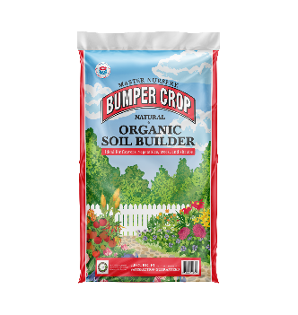
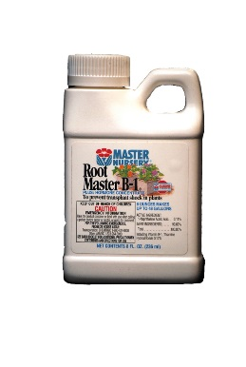

We recommend:

Master Nursery Bumper Crop is an excellent compost that will enrich your soil, and Root Master B-1 will help prevent transplant shock, and help your plants get established quickly.
Step 1: Start by digging a hole twice as wide as the plant's rootball, and slightly deeper. The rootball is all the roots and soil that are in the container you purchased the plant in.
Step 2: Mix Bumper Crop into the pile of soil you dug out of the hole until it's blended about 50/50. If you have clay in your soil, your soil is very alkaline, or the spot you are planting doesn't drain well, we also recommend adding gypsum to the mixture at this time. It will break up clay, increase drainage, and balance soil pH.
Step 3: Put some of the mixture in the bottom of the hole, then remove your plant from its container, being careful not to break up the rootball. You can gently pull some of the roots out from around the sides if they are wrapped around, just don't break up the soil because that can shock your plant. Set your plant in the hole, making sure that the top of the rootball is level with the surrounding ground. It's very important not to bury your plant too deep or plant it too high.
Step 4: Now fill in around the sides of the rootball with your Bumper Crop mixture. You can push it down around the roots to fill in, but be careful not to pack it too tightly. Save a little of the soil aside to make a ridge around the plant to hold water.
Step 5: Mulch around the base of the plant with Bumper Crop, then water slowly and thoroughly. Allow the moat around your plant to fill completely with water. You can mix some Root Master B-1 in with the water at this time, or mix it in a watering can and apply it immediately afterward.
Step 6: As you water, the soil will settle around the roots, and you may have to add more. After adding more soil, be sure to water again to ensure that you filled in all the gaps around the roots.
Care Instructions continued on reverse

Maintenance: Continue applying Root Master B-1 about once per week for the first month. Proper watering is crucial to get your plant established. Water 2 times per week in the Spring and Fall, 3 times per week in the summer, and occasionally as needed in the winter.
When you water, be sure to give several gallons of water slowly so it can soak deeply. This is very important on trees and larger shrubs. On smaller plants, give them enough that the soil is saturated all the way around the roots. If your plant is in a container, you will need to water more frequently. During Spring and Fall, several times per week, depending on weather. Summer can be up to daily watering if it's very hot. Smaller pots will need to be watered more frequently than larger pots. When you water a potted plant, soak it slowly from the top of the soil, and give enough water that it runs out the bottom of the pot.
The other important step to maintaining a healthy plant is fertilizing regularly. We recommend Gro-Power Plus fertilizer, which is an all-purpose that can be used on anything from roses to lawns, as well as shrubs and trees. Just apply it 3 times per year, around Valentine's Day, Memorial, Day, and Labor Day.

