VEGETABLES
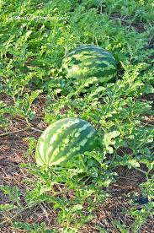
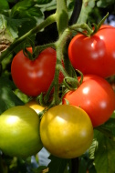
What to plant when

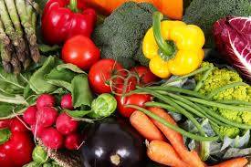
Plant in Spring
For Spring through Fall Harvest:
Artichoke, Asparagus, Beans, Cantaloupe, Corn, Cucumber, Eggplant, Melons,
Okra, Peppers, Potatoes, Pumpkins, Rhubarb (needs afternoon shade), Squash,
Tomatillos, Tomatoes, Watermelon

Plant in Fall
For Winter and Spring Harvest:
Arugula, Beets, Broccoli, Brussels Sprouts, Cabbage, Carrots, Cauliflower,
Celery, Collards, Fava Beans, Garlic Kale, Lettuce, Mustard Greens, Onions,
Peas, Radish, Spinach, Swiss Chard, Turnips
*Certain things like onions, garlic, and carrots can be grown year round with the right conditions. Ask us for more information.

Cagliero Ranch Nursery-2700 W. Devonshire Ave., Hemet, CA 92545
(951) 766-7755 www.caglieroranchnursery.com

