Caring for Roses
Cagliero Ranch Nursery-2700 W. Devonshire Ave., Hemet, CA 92545
(951)766-7755 www.caglieroranchnursery.com

These are some products that we recommend:
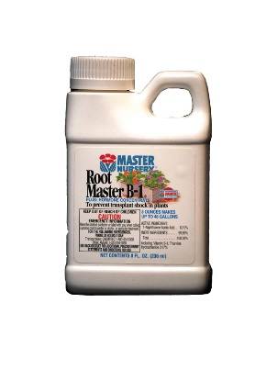
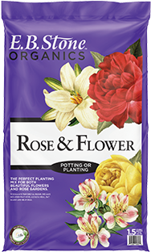
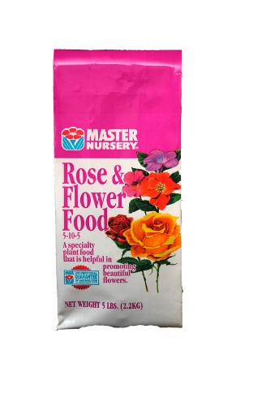

E.B. Stone Rose and Flower Mix, Master Nursery Rose and Flower Food, and Root Master Vitamin B-1.

Where to Plant
Be sure to choose a location with at least 6 hours of direct sunlight for best bloom. Plant so that each rose has 3-4 ft. of width around it, depending on variety. This will allow air circulation around the plant, helping to prevent fungal diseases such as powdery mildew. You will also want to choose a location where your roses will not be hit by sprinkler water, as this can spread disease.
Planting
Spring, fall, and winter are the best seasons to plant roses. Try to avoid summer because it can be harder to get them established with our heat. We recommend amending the soil with Rose Planting Mix (pictured above). This will enrich the soil, add nutrients, and help break up clay to increase drainage. If you're in an area with clay in the soil, or you are planting your rose in a poorly drained spot, you can also add gypsum when planting, which will help to break up the clay. Once planted, use Root Master B-1 to help prevent transplant shock. It also contains a root growth hormone, which will help your rose get established.

Fertilizing
Roses like to be fed regularly during the growing season. Start feeding your roses around the end of March, and continue to feed monthly until the end of October. We recommend E.B. Stone Organic Rose and Flower Food or Master Nursery Rose and Flower Food. Always be sure to water thoroughly before and after applying fertilizer. It's also a good idea to mulch around the base of your roses with Rose Planting Mix or a good compost a few times a year. This will help keep down weeds, retain moisture, and enrich the soil.
Watering
Roses need to be watered regularly, but they also require good drainage. That's why it's important to add organic materials when planting. During summer, your roses will need a deep soak about 3 times per week. Spring and fall would be about two times per week (depending on weather), and winter would be as needed, if there's no rain or it's unseasonably warm. Remember, don't reduce the amount of water you're giving, just reduce the frequency during the cooler seasons. Roses need enough water at a time that their entire root system gets soaked, 2 or 3 gallons at least. These instructions are for roses planted in the ground. Container plants will require water more often.
Pruning
Prune off spent blooms throughout the year by cutting branches at 45 degree angle above a set of leaves. On a hybrid tea rose, be sure to cut above a set of 5 leaves. Do your heavy pruning in January. You can cut out dead canes at this time, and prune your roses back halfway to two-thirds of the way from their normal height. Be sure to attend our rose pruning demonstration in January. Check with us in December for dates and times.

