Fruit Tree Pruning Instructions
Cagliero Ranch Nursery- 2700 W. Devonshire Ave., Hemet, CA 92545
(951)766-7755 www.caglieroranchnursery.com
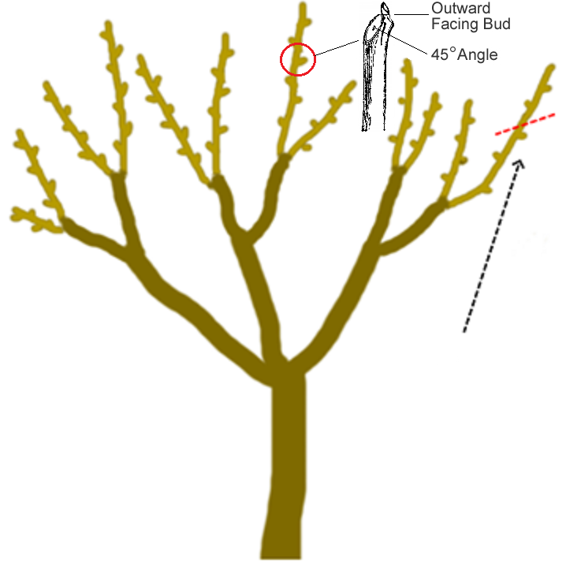
January is the month for fruit tree pruning in Southern California. Keep in mind that this applies to deciduous fruit trees only (trees that go dormant in the winter), such as apples, peaches, pears, plums, etc. The goal here is to shape and control the size of the tree, while not cutting off so much that it will inhibit fruit production. Generally, we recommend to:
-Prune back branches one quarter to one third of the way. Make all cuts at a 45 degree angle, above a bud (the buds are small bumps on the branch).
-Thin out crossing branches, some center branches, and any dead twigs or branches. You do this to allow light into the center of the tree, and to allow wind to pass through the canopy.
-Apply pruning sealer to any cuts made on branches bigger around than your thumb (about half an inch or so). This is especially important for any branches you cut off the trunk of the tree.
-Apply tree trunk paint to the trunk of the tree and any higher branches that will be exposed to the sun in summer.-Clear fallen leaves, branches, and debris from around the base of the tree and dispose of them, to help stop the spread of disease.

