Rose Pruning Instructions
Cagliero Ranch Nursery 2700 W. Devonshire Ave., Hemet, CA 92545
(951)766-7755 www.caglieroranchnursery.com

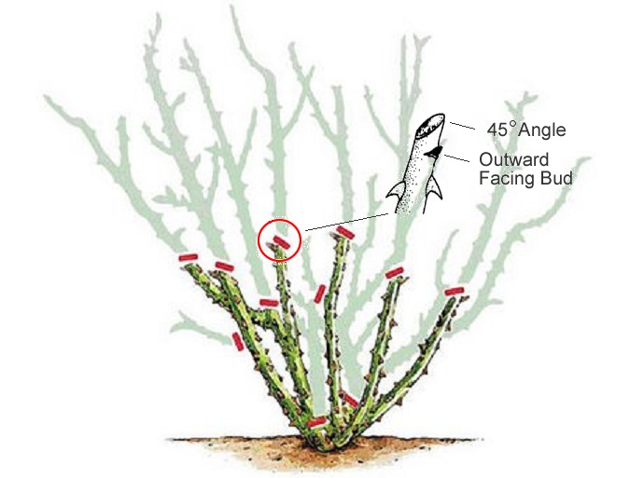

January is the time to prune roses here in Southern California. We recommend pruning rose canes (branches on roses are referred to as "canes") back about one half to two thirds of the original size. Make cuts at a 45 degree angle, so that water won't collect in the end of the canes. Once you have cut the canes down, look at the center of the rose bush. If you see any canes that are crossing over each other, remove one so that no canes are crossing. After that, prune some canes out of the center of plant, so that you have several canes (between 5 and 8) growing outward. The idea is to have the middle of the rose bush open, so it doesn't get overgrown and air can circulate through. Proper air circulation can cut down on rose disease occurrence. Also, be sure to remove any dead canes at this time. The last thing you will want to do is remove any leaves and debris from around the base of the rose and dispose of them, to help prevent the spread of rose diseases. Mulch can be added around the base after this step, if so desired.

